

**AMERICAN INTERNATIONAL UNIVERSITY–BANGLADESH (AIUB)**

**FACULTY OF SCIENCE & TECHNOLOGY**

**DEPARTMENT OF CS**

# Introduction to Database

**Fall 2020-2021**

**Section: F.**

**Supervised By**

**Kawser Irom Rushee**

**Project Topic**

**Donation System**

**Group member**

|  |  |
| --- | --- |
| **Name** | **ID** |
| **NOKIBUL ARFIN SIAM** | **21-44793-1** |
| **MD. WALID** | **21-44838-1** |

**Case Study:** In a donation management system, a donator donates on charity. Donation is received by charity employees. A donator has National_ID, Name, Photo, Password, Location. Donation has D_type, D_amount and D_ID. Charity emp receives the donation and is identified by E_ID, E_Name, E_Password, E_Status, E_Salary, E_Phone. Charity_employees are managed by an admin who has attributes of A_UserName, A_ID, A_Password. Admin creates accounts of the employees.Charity employees also collect donation from donate box which has attribute of ID and Location.Admin is also registered to the donate box.Admin approves needy people for donation. Needy people’s attributes are composed of National_ID, N_name, N_phone, Location, Family_members and Income.

***ER DIAGRAM***

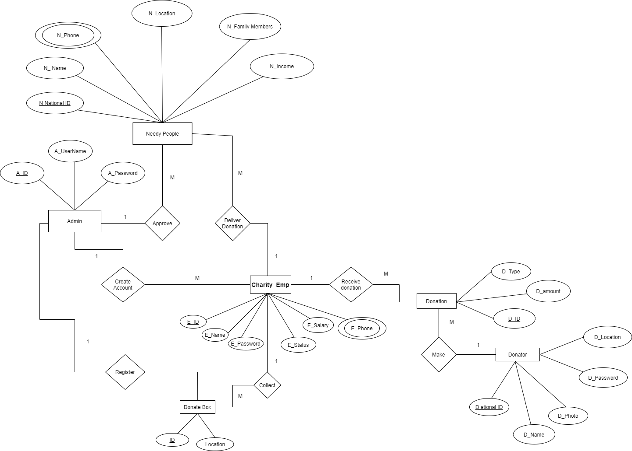

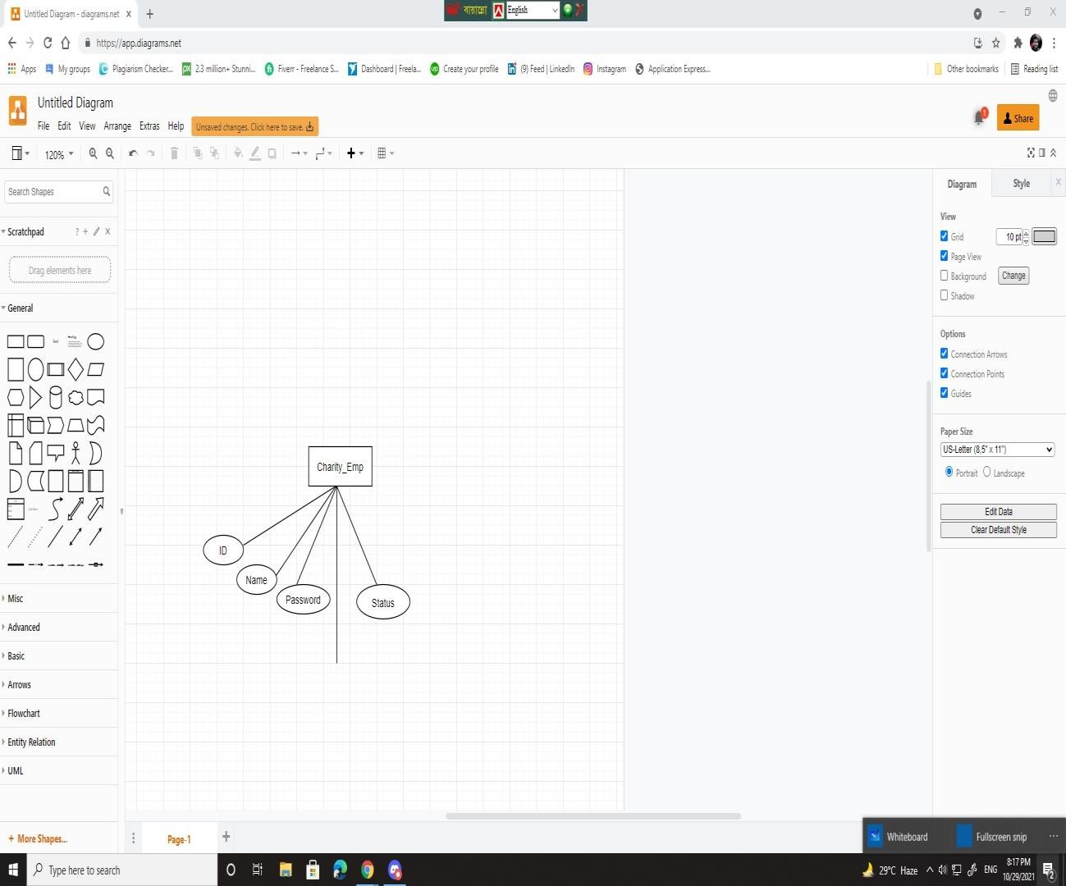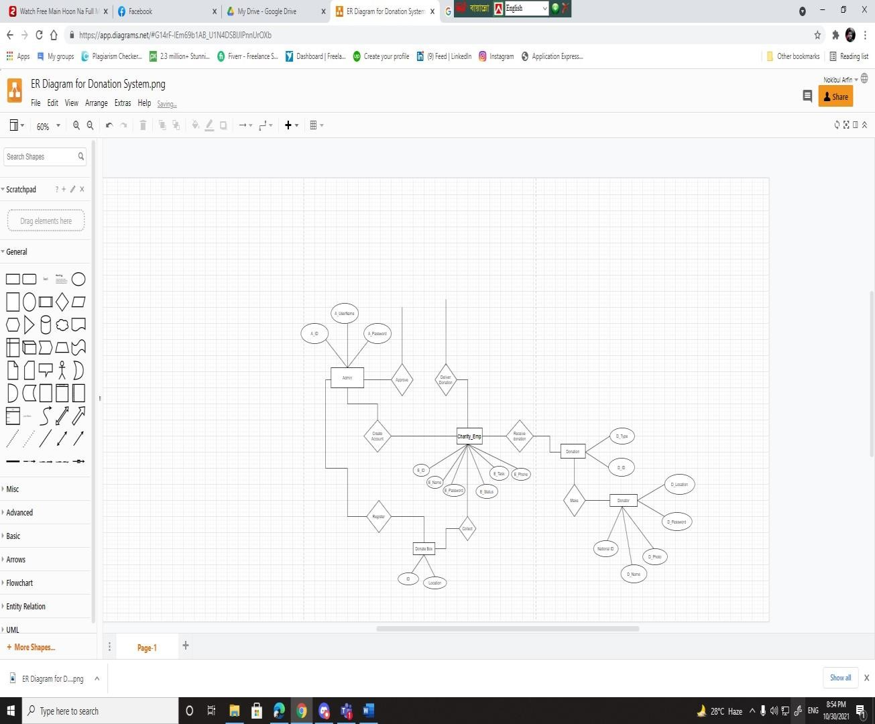

***NORMALIZATION***

**Receive Donation:**

**UNF**

Receive Donation (D_Type, D ID, D_amount, E ID, E_Name, E_Password, E_Status, E_Salary, E_Phone)

**1NF:** E_phone is multivalued attribute.

**2NF:** E ID, E_Name, E_Password, E_Status, E_Salary, E_Phone

D ID, D_Type, D_amount, E ID

**3NF:** D ID, E ID

D_ID, D_amount

D ID, D_Type

**Make:**

**UNF**

Make (D_Location, D_Password, D National ID, D_Name, D_photo, D ID, D_Type, D_amount)

**1NF:** There is no multivalued attribute.

**2NF:** D ID, D_Type D_amount

D National ID, D_Password, D_Location, D_Name, D_photo, D ID

**3NF:** D National ID, D_Type, D ID

D National ID, D_name, D_Location,

D national ID, D_photo

**Create Account:**

**UNF**

Create Account (E ID, E_Name, E_Password, E_Status, E_Salary, E_phone, A ID, A_UserName, A_Password)

**1NF:** E_phone is multivalued attribute.

**2NF:** A ID, A_UserName, A_Password

E ID, E_Name, E_Password, E_Status, E_Salary, E_phone, A ID

**3NF:** E ID, E_Name, E_Password, E_Status, E_Salary, E_phone

A_UserName, A_Password

E ID, A ID

**Register:**

**UNF**

Register (A ID, A_UserName, A_password, ID, Location)

**1NF:** There is no multivalued attribute.

**2NF:** ID, Location

A ID, A_UserName, A_password, **ID**

**3NF:** A ID, **ID**

**Collect:**

**UNF**

Register (E ID, E_Name, E_Password, E_Status, E_Salary, E_phone, ID, Location)

**1NF:** E_phone is multivalued attribute.

**2NF:** ID, Location

E ID, E_Name, E_Password, E_Status, E_Salary, E_phone, ID

**3NF:** E ID, E_Name, E_Password, E_Status, E_Salary, E_phone

E ID, ID

**Deliver Donation:**

**UNF**

Deliver Donation (N National ID, N_Name, N_phone, N_Location, N_Family Members, N_Income, E ID, E_Name, E_Password, E_Status, E_Salary, E_phone)

**1NF:** There is 2 multivalued attribute N_Phone, E_Phone.

**2NF:** E ID, E_Name, E_Password, E_Status, E_Salary, E_phone

N National ID, N_Name, N_phone, N_Location, N_Family Members, N_Income, E ID

**3NF:** N National ID, E ID

N National ID, N_Name, N_Family Members, N_Income

N_phone, N_Location,

**Approve:**

**UNF**

Approve (A ID, A_UserName, A_password, N National ID, N_Name, N_phone, N_Location, N_Family Members, N_Income)

**1NF:** N_phone is multivalued attribute.

**2NF:** A ID, A_UserName, A_password

N National ID, N_Name, N_phone, N_Location, N_Family Members, N_Income, A ID

**3NF:** N National ID, A ID

N National ID, N_Name, N_Family Members

N_phone, N_Location, N_Income

***TABLE CREATION***

***Final Table:***

**Donator:** D_Location, D_Password, D ational ID, D_Name, D_photo.

**Contact Donator:** D National ID, D_name, D_Location,

**Donation:** D_Type, D_ID, D_amount

**Charity Employee:** E ID, E_Name, E_Password, E_Status, E_Task, E_phone

**Admin:** A ID, A_UserName, A_password

**Needy People:** N National ID, N_Name, N_phone, N_Location, N_Family Members,

N_Income.

**Contact Needy people:** N National ID, N_Phone, A ID

***Create Table:***

1. **Donator:**

create table donator(D_Nid number(6,0), D_name varchar2(15),D_password number(13,0),D_Location varchar2(20));

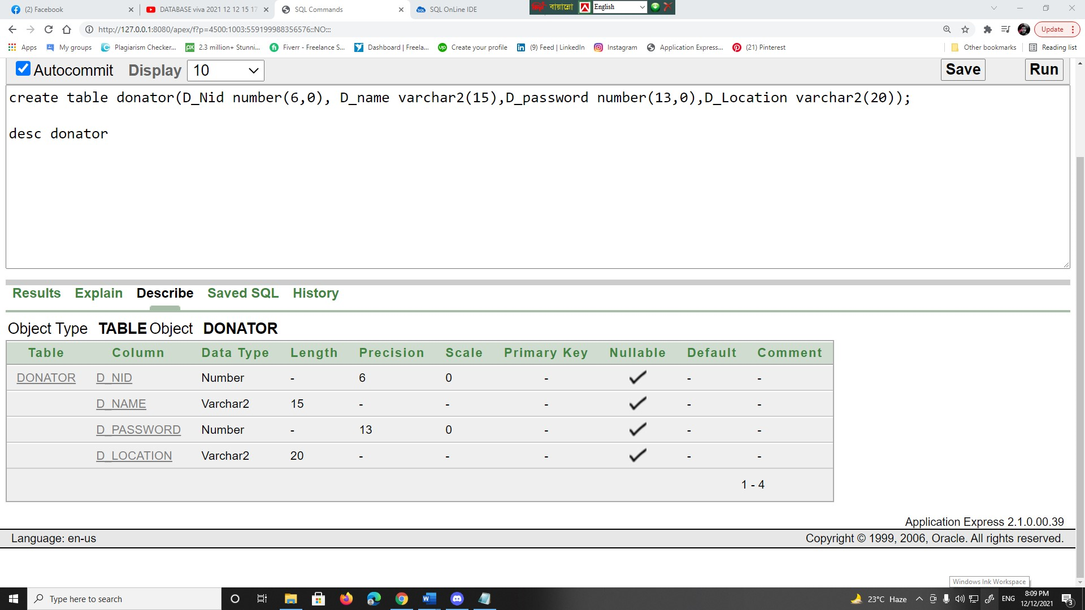

1. **Contact Donator:**

create table Contact_Donator(Nid number(7,0)primary key not null, D_name varchar2(12),D_location number(7,0));

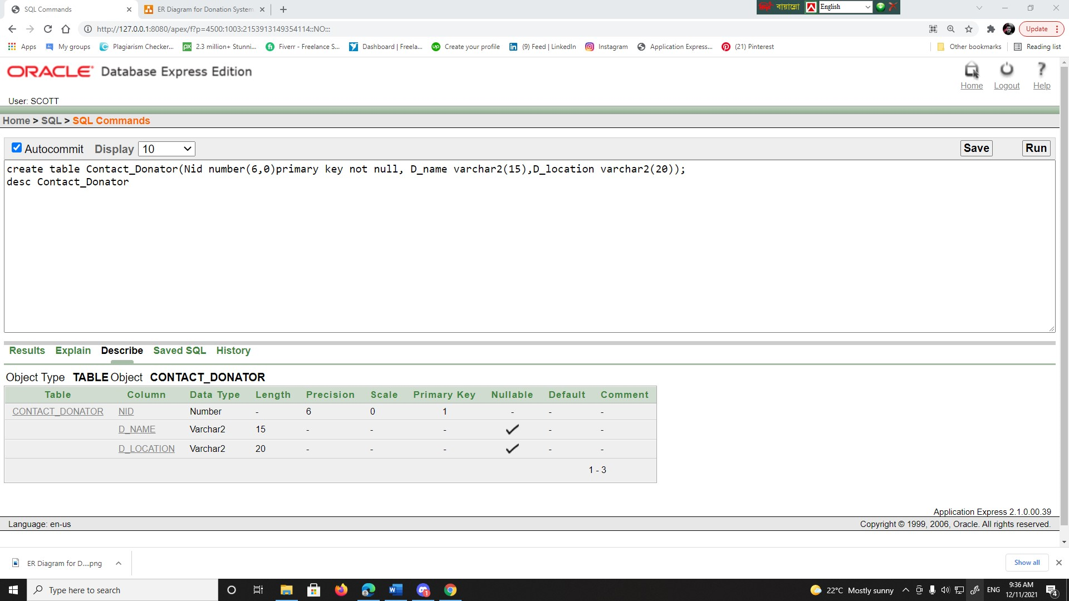

1. **Donation:**

create table donation(D_id number(6,0)primary key not null,D_type varchar2(15),D_amount int);

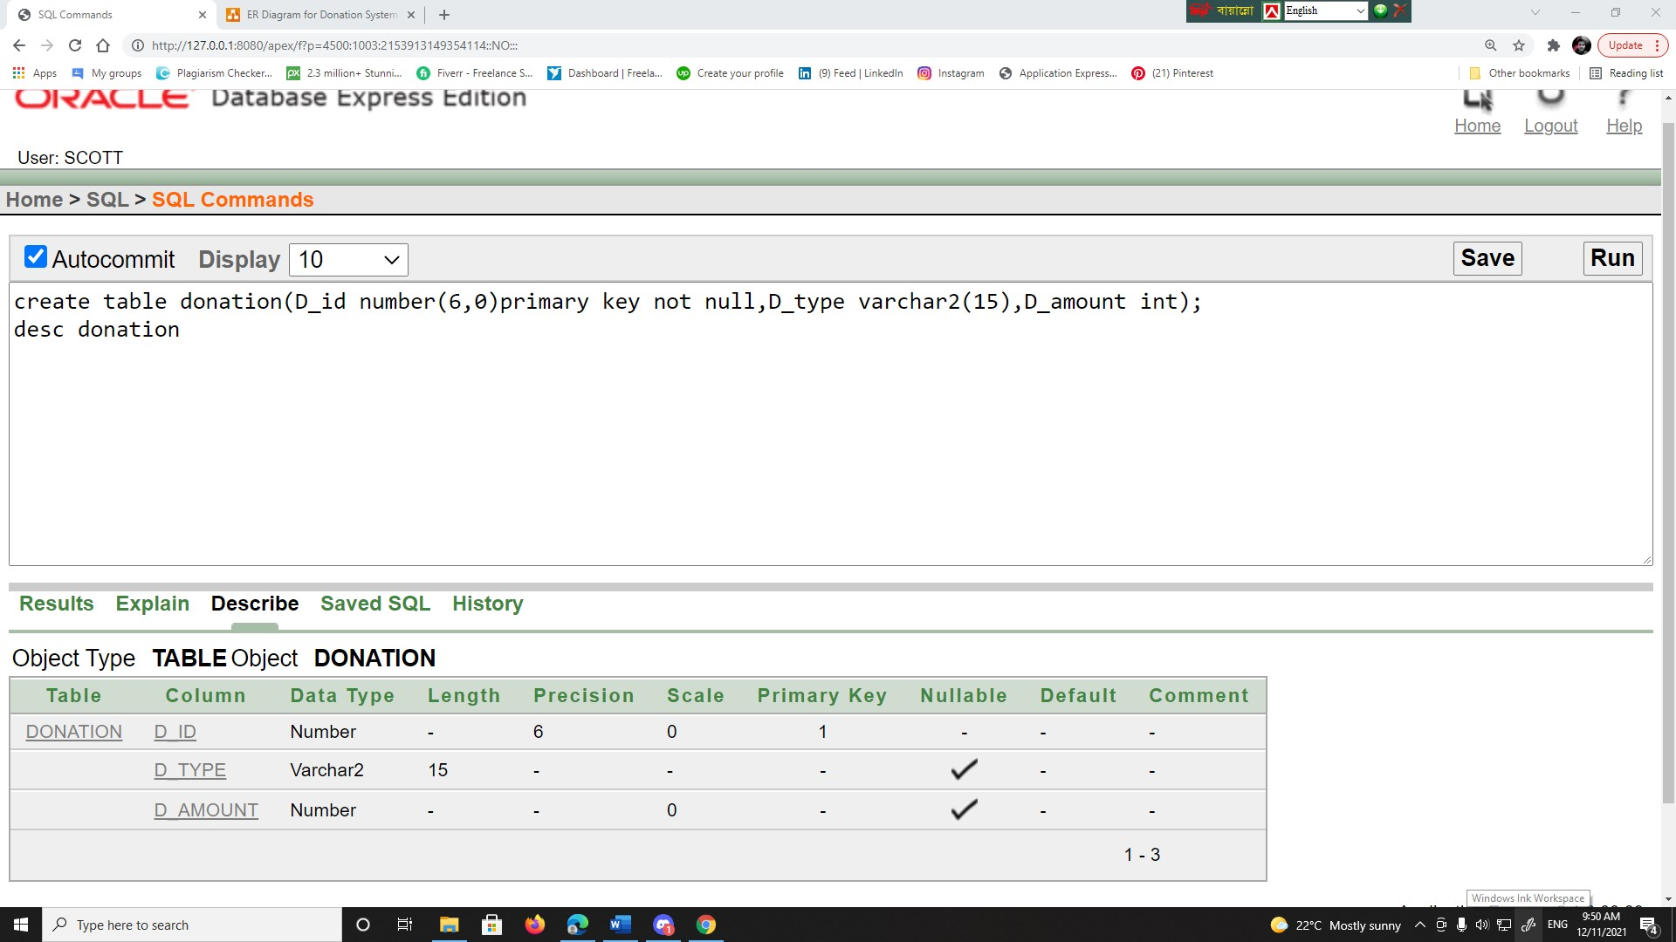

1. **Charity Employee:**

create table Charity_Employee(E_id number(6,0)primary key not null, E_name varchar2(15),E_password number(13,0), E_status varchar2(20), E_Salary int, E_phone number(20));

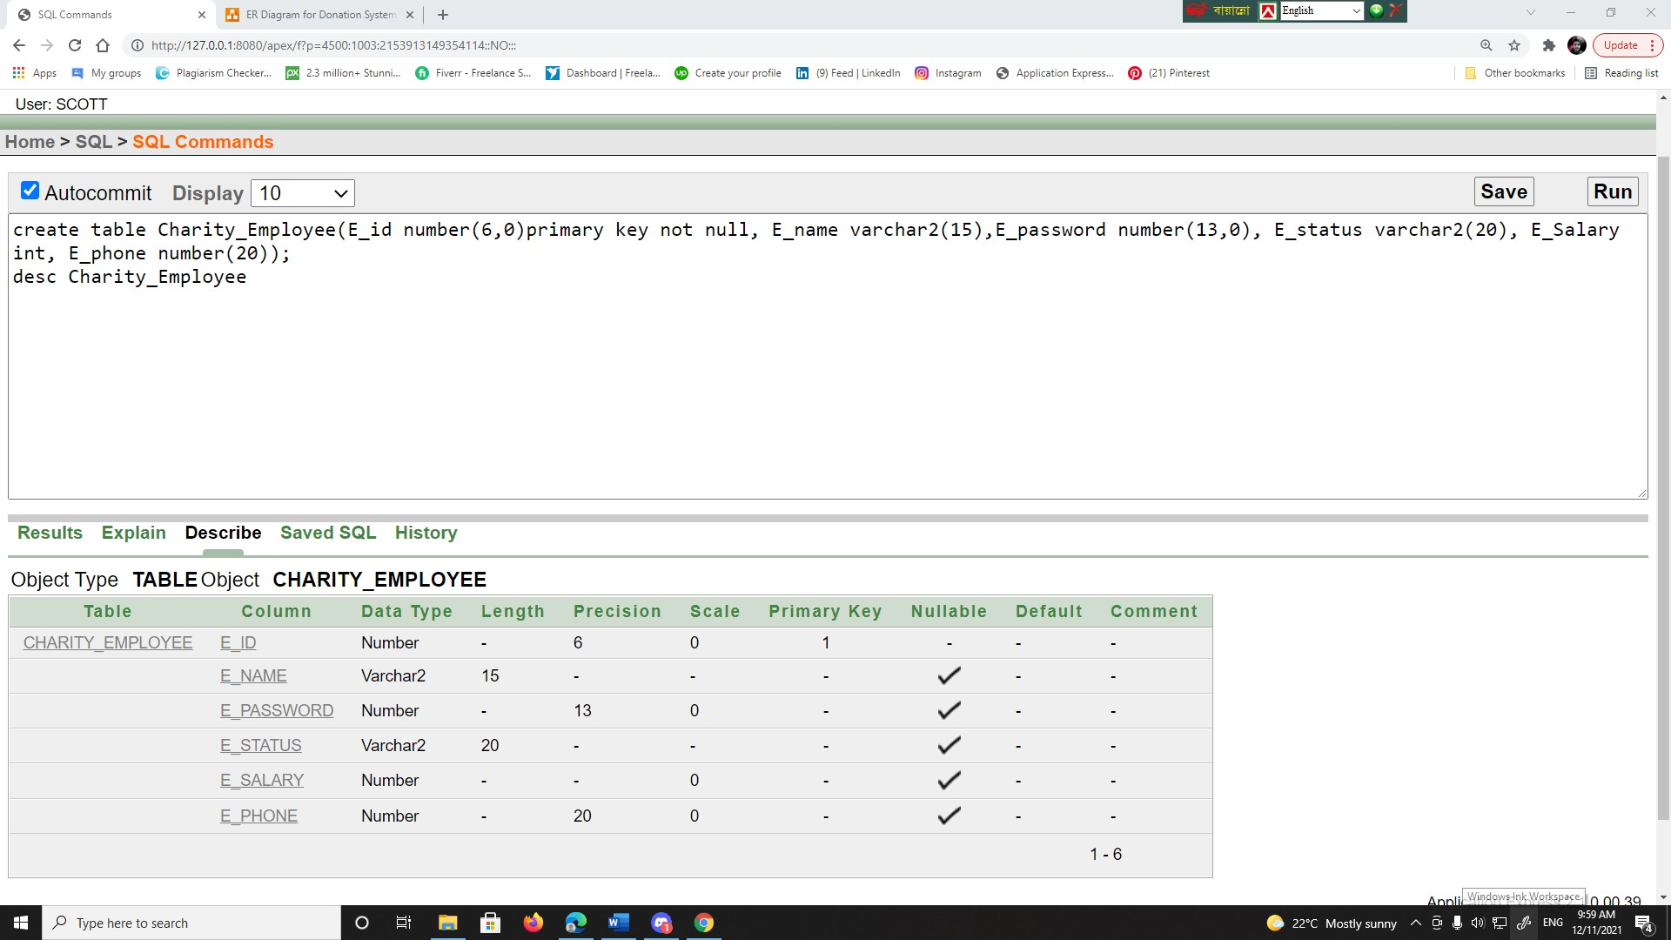

1. **Admin:**

create table admin(A_id number(7,0) primary key not null,A_password number(15),A_username varchar2(4)not null);

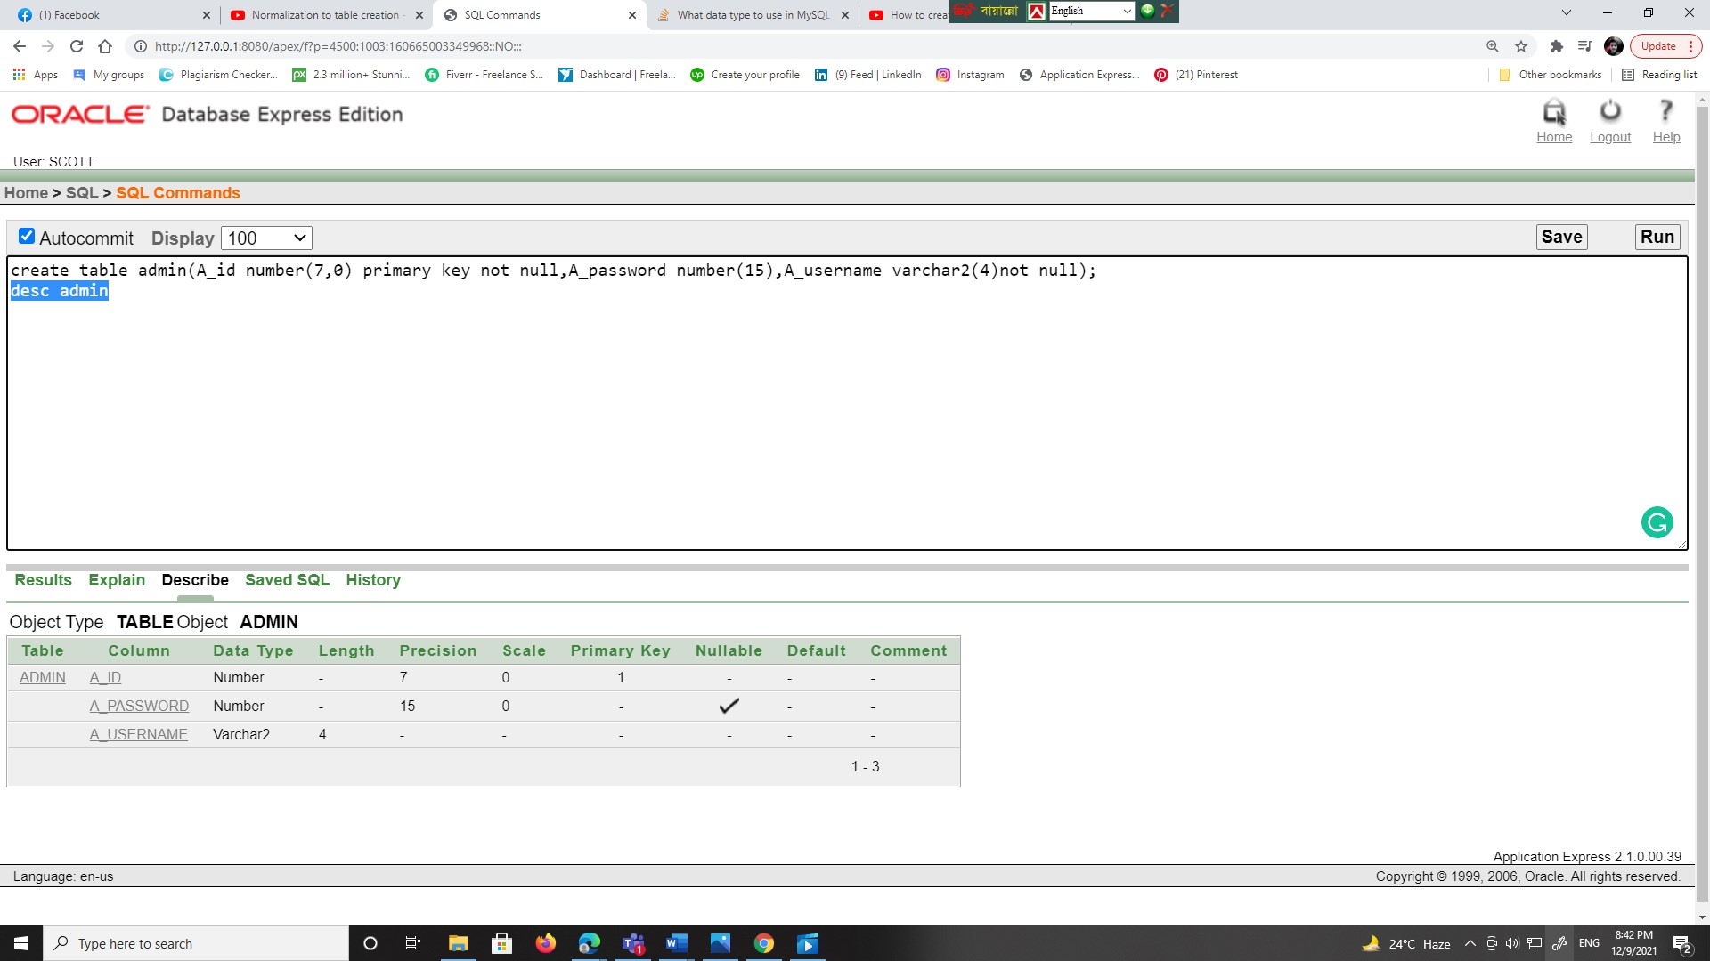

1. **Needy People:**

create table needy_people(N_Nid number(6,0)primary key not null,N_name varchar2(15),N_phone number(20),N_location varchar2(20),N_familymembers number(20),N_income int);

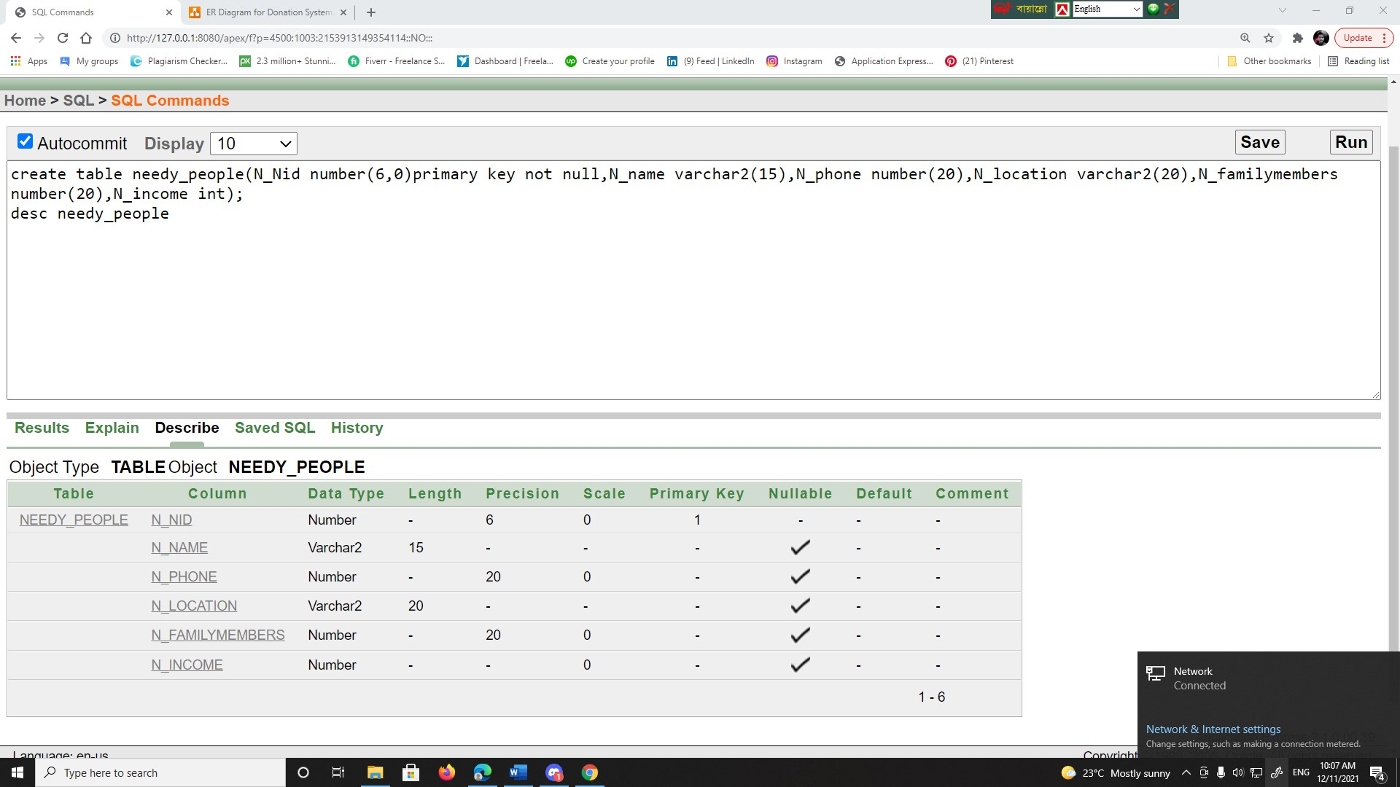

1. **Contact Needy People:**

create table Contact_Needy_people(N_nid number(6,0)not null ,N_phone number(20),A_id number(7,0),primary key(N_nid),foreign key(A_id) references admin(A_id));

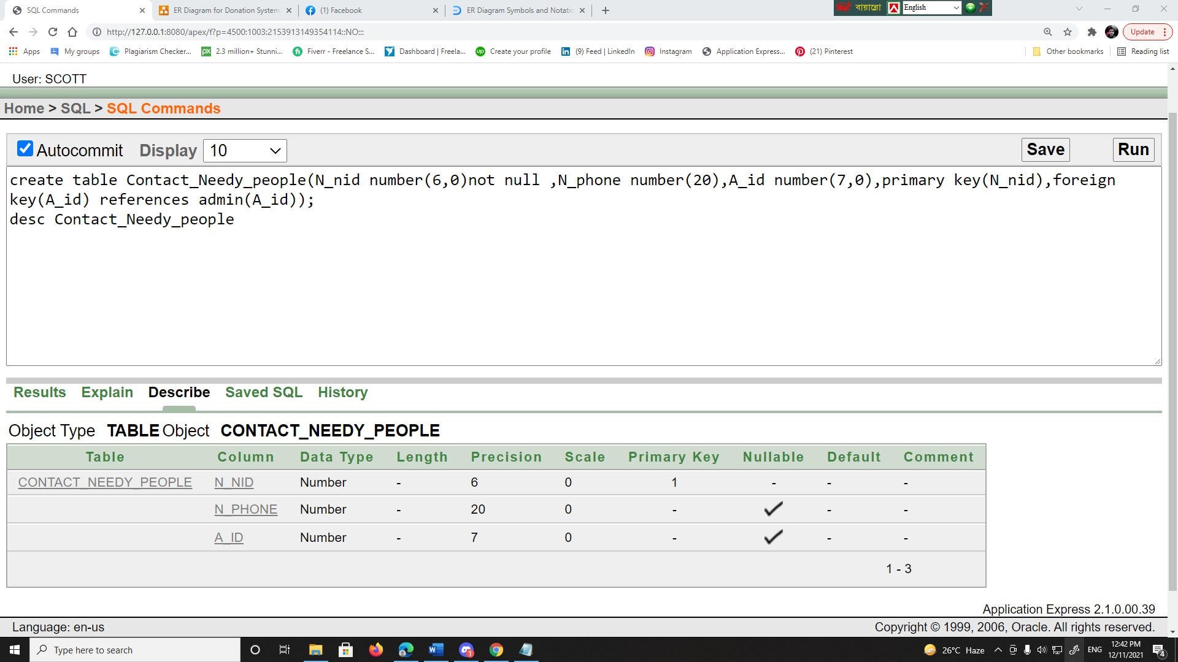

***DATA INSERTION***

1. **Donator:**

insert into donator values(10523 , 'farhan amin' , 4134340 , 'sylhet');

insert into donator values(114012 , 'nokibul arfin' , 1215403 , 'sohid faruk road');

insert into donator values(121013 , 'shariar sahill' , 34123203 , 'jonson road');

select * from donator;

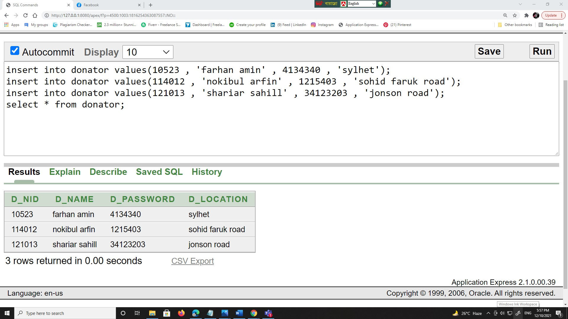

1. **Contact Donator:**

insert into Contact_Donator values(10523 , 'farhan amin' , 'sylhet');

insert into Contact_Donator values(114012 , 'nokibul arfin' , 'sohid faruk road');

insert into Contact_Donator values(121013 , 'shariar sahil' , 'jonson road');

select * from Contact_donator;

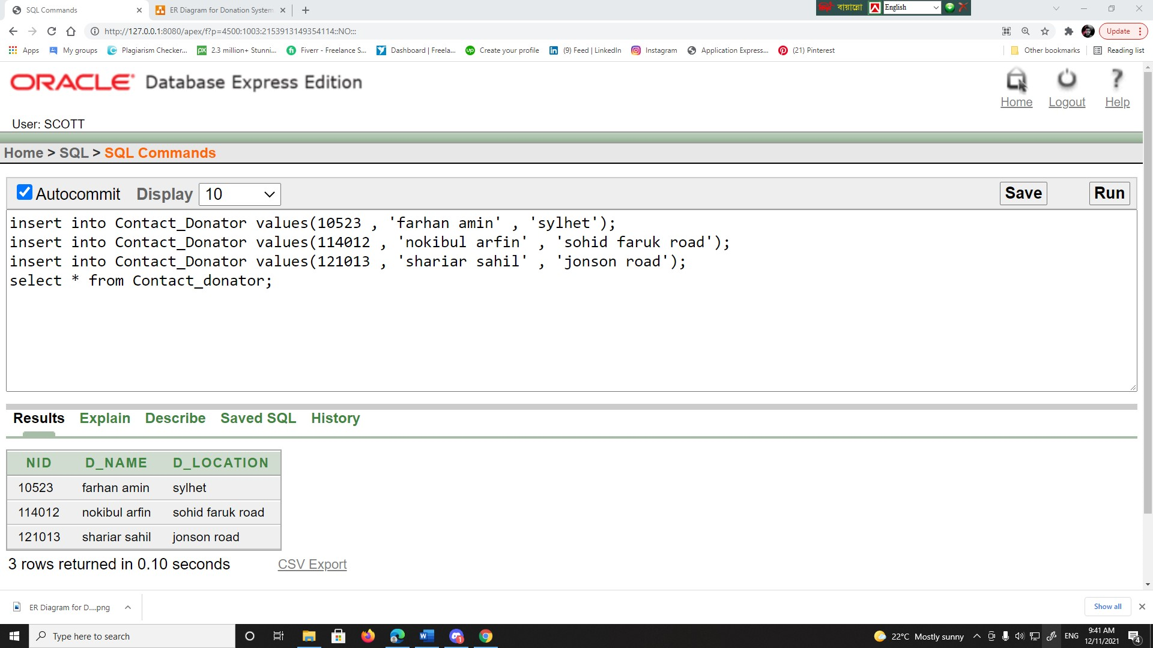

1. **Donation:**

insert into Donation values(10523 , 'Cash' , 30000);

insert into Donation values(11401 , 'Check' ,20000);

insert into Donation values(12101 , 'Cash' ,10000);

select * from donation;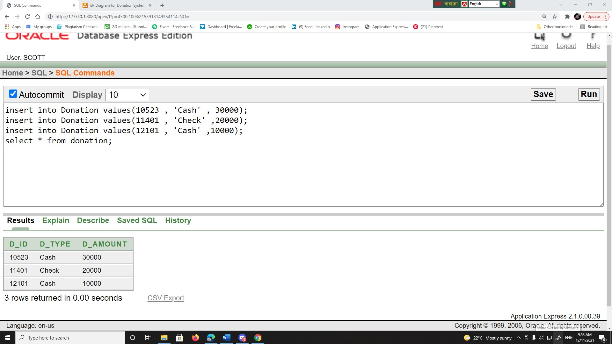

1. **Charity Employee:**

insert into Charity_Employee values(10523 , 'Siam' , 23415 ,'manger' ,'30000',01575267980);

insert into Charity_Employee values(10524 , 'farhan' , 21415 ,'j manager' ,'20000',01575267981);

insert into Charity_Employee values(10525 , 'sahil' , 22415 ,'clark' ,'10000',01575267982);

select * from Charity_Employee

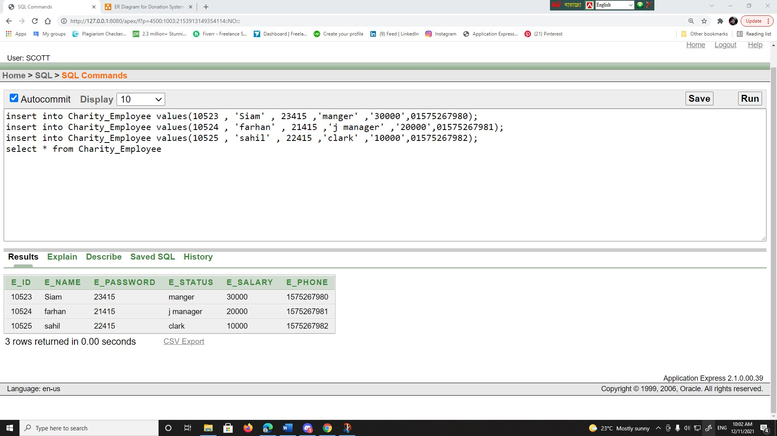

1. **Admin:**

insert into admin values(10523 , 23415 ,'aaaa');

insert into admin values(10524 , 21415 ,'bbbb');

insert into admin values(10525 , 22415 ,'cccc');

select * from admin

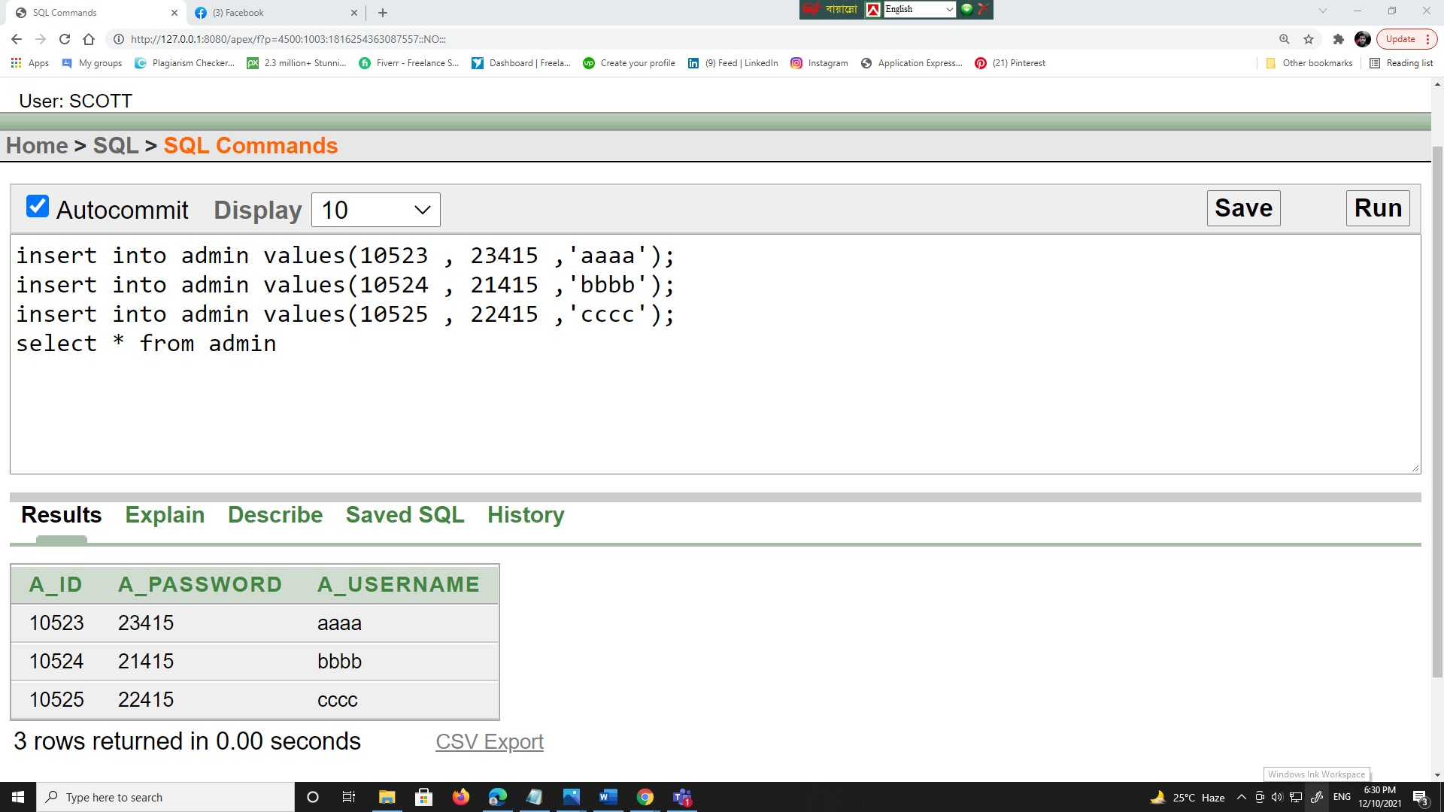

1. **Needy People:**

insert into needy_people values(10522 , 'Siam' ,01575267980 ,'aaaaa' ,5 ,'5000');

insert into needy_people values(10523 , 'farhan' ,01575267981 ,'bbbbb' , 5,'4000');

insert into needy_people values(10524 , 'Sahil' ,01575267982 ,'ccccc' ,5 ,'3000');

select * from needy_people

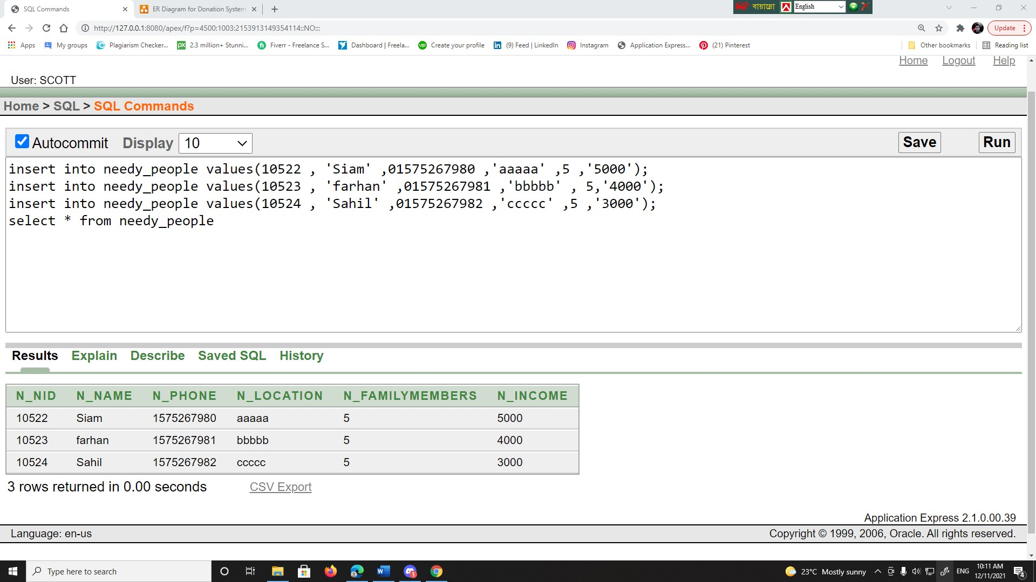

1. **Contact Needy People:**

insert into Contact_Needy_People values(10522 , 01575267980 , 10523);

insert into Contact_Needy_People values(10523 , 01575267981 , 10524);

insert into Contact_Needy_People values(10524 , 01575267982 , 10525);

select * from Contact_Needy_People

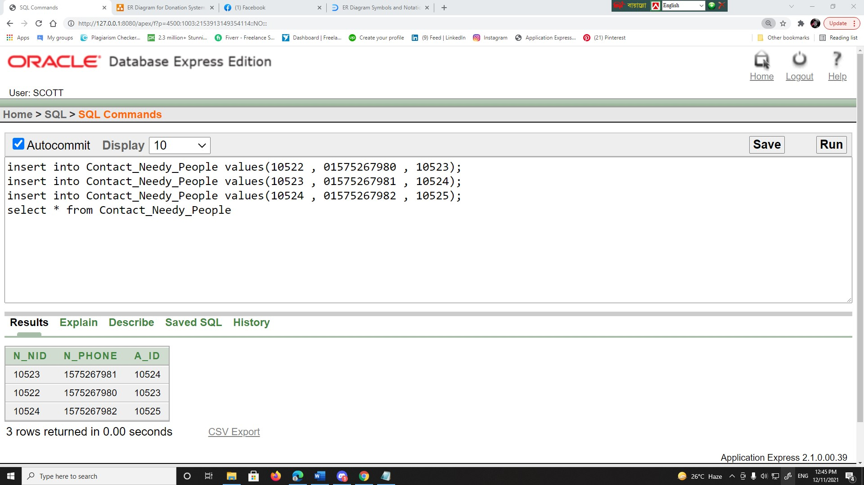

***SUBQUERY***

1:

Show all details of the maximum donator.

SELECT * FROM donator , donation WHERE d_amount=(SELECT max (d_amount) from donation) and donator.D_Nid=donation.D_id*;*

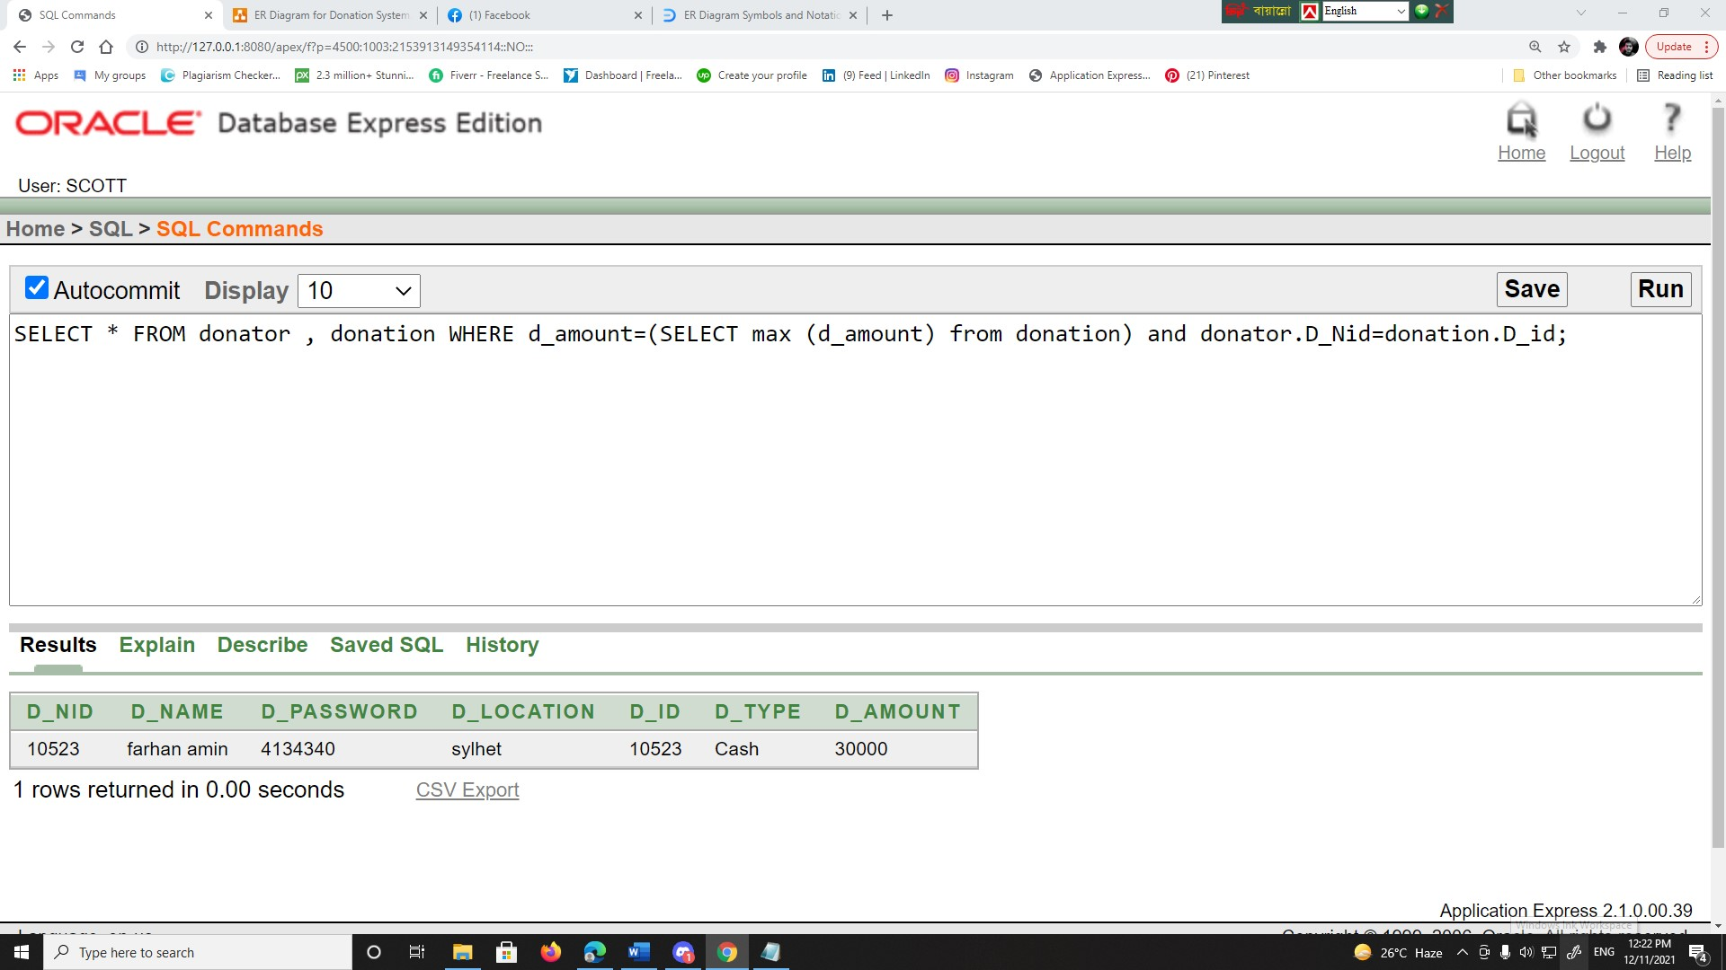

2:

Show all details of the lowest income people in needy people table.

SELECT * FROM needy_people WHERE n_income=(SELECT min (n_income) from needy_people);

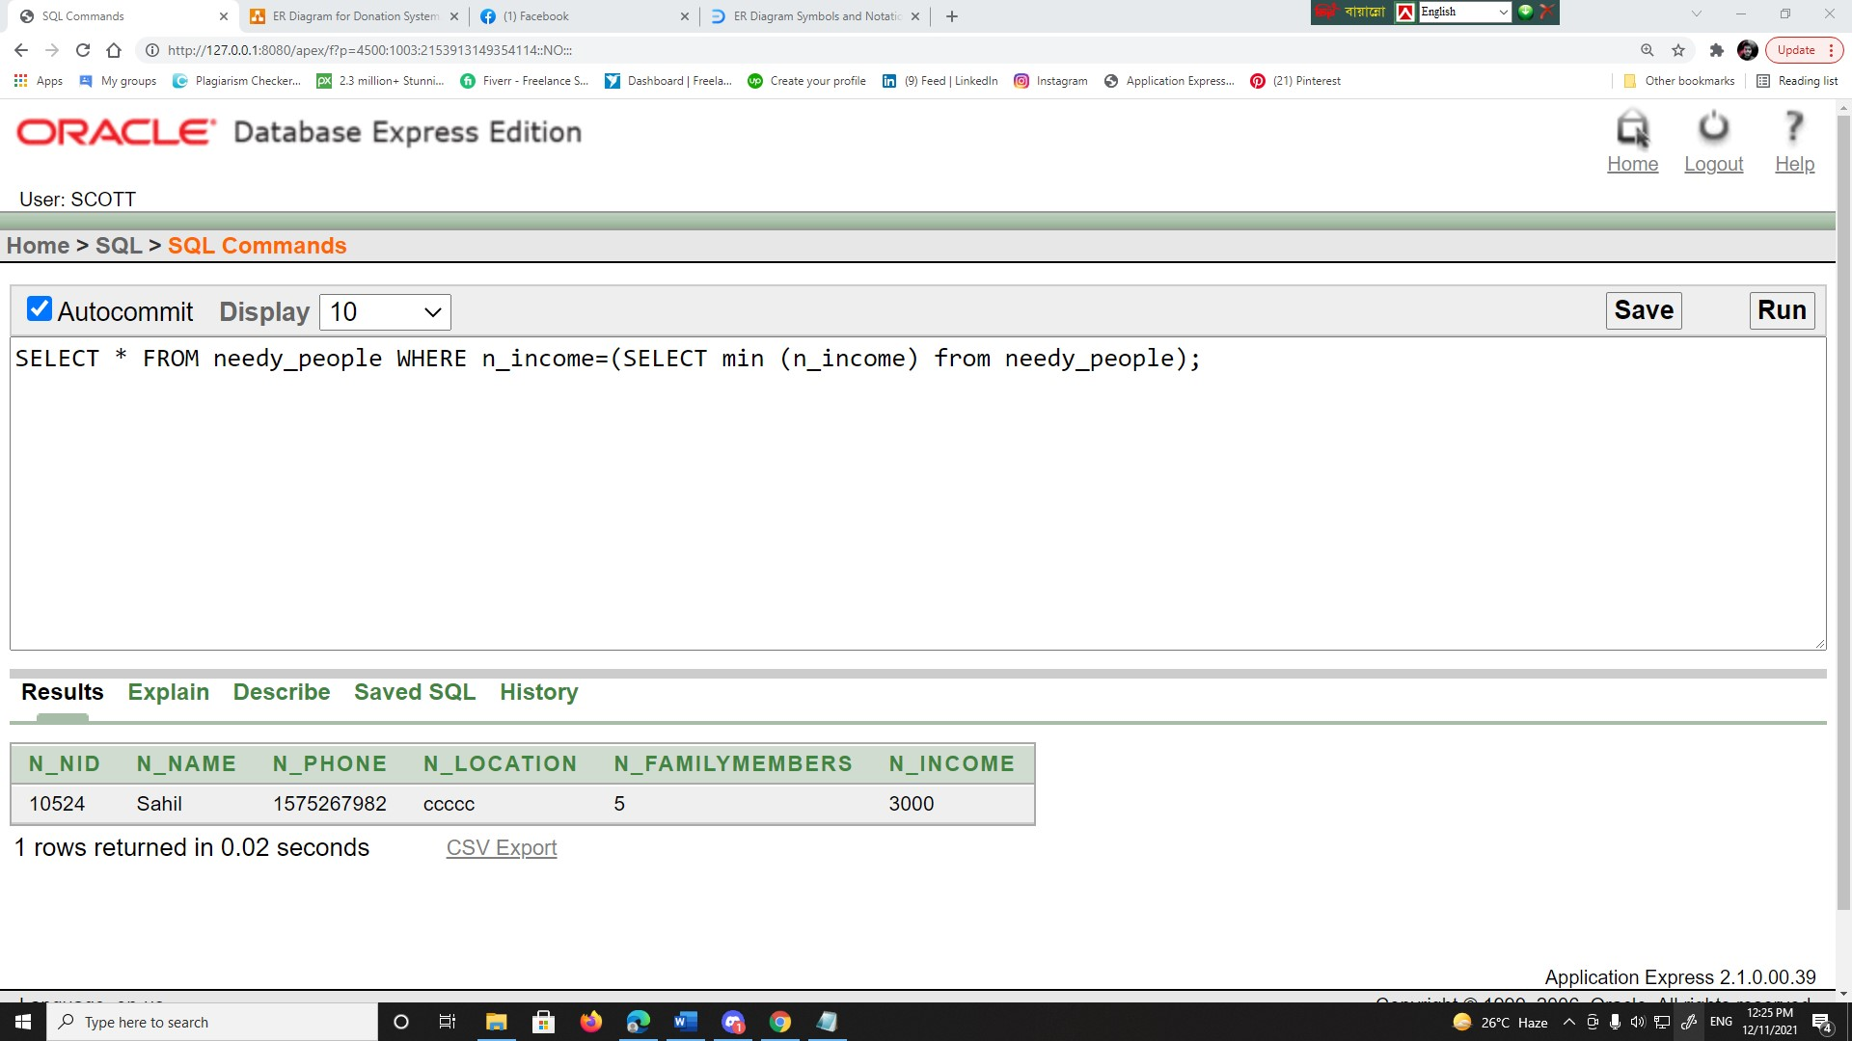

3:

Display all employee names whose has more or equal than 20000 salary.

select * from Charity_Employee where E_id in (select E_id from Charity_Employee where e_salary>= 20000);

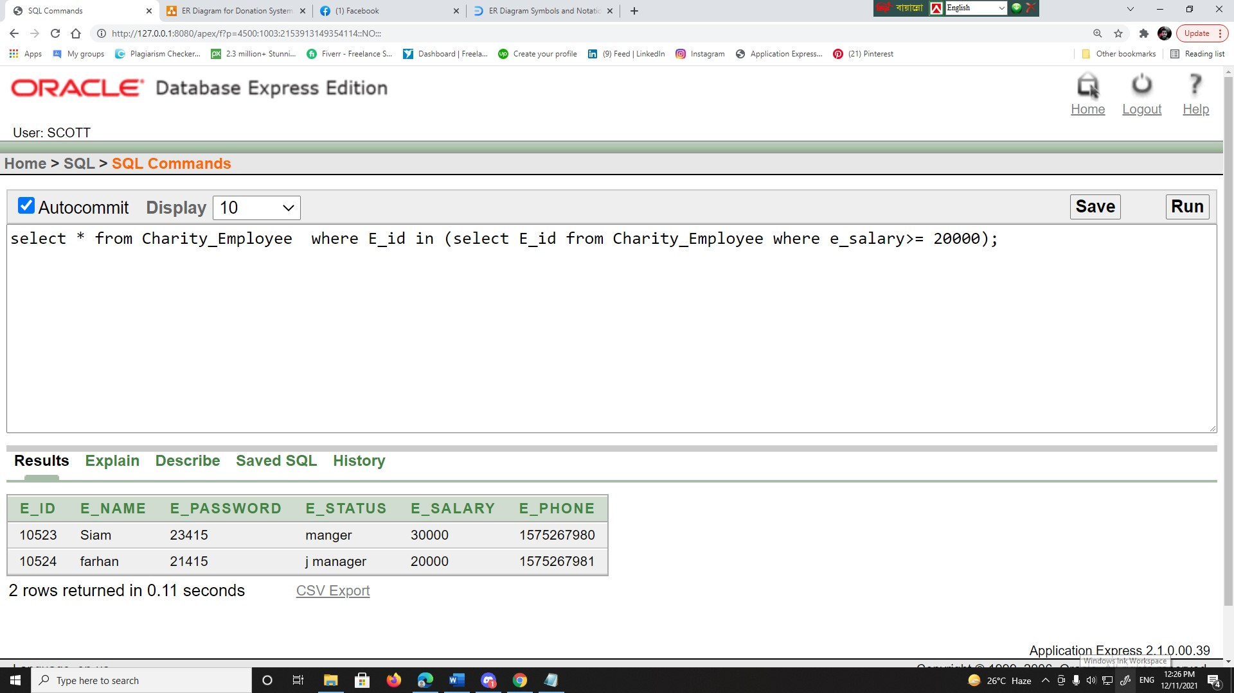

***JOINING***

**Equi-join:**

4:

Fimd out donator name who has donated 30000.

SELECT d_name FROM donator, donation where donator.D_Nid= donation.D_id and d_amount=30000

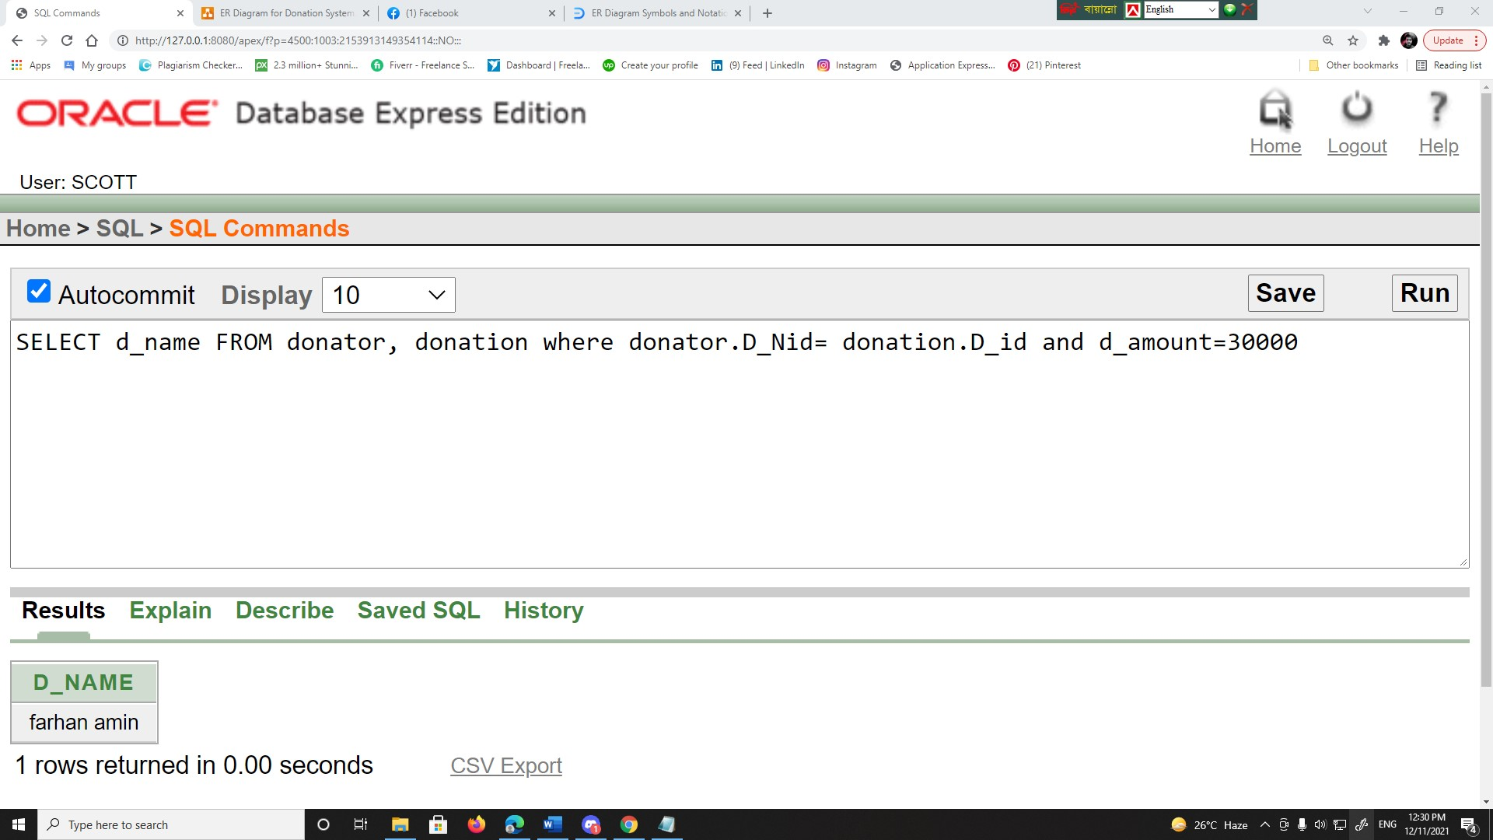

**Non-Equi-join:**

5:

Display all details of needy people when income between 3500 and 10000 live but out of sylhet

SELECT * FROM needy_people WHERE n_income BETWEEN 3500 and 10000 and needy_people.N_location<>'sylhet'

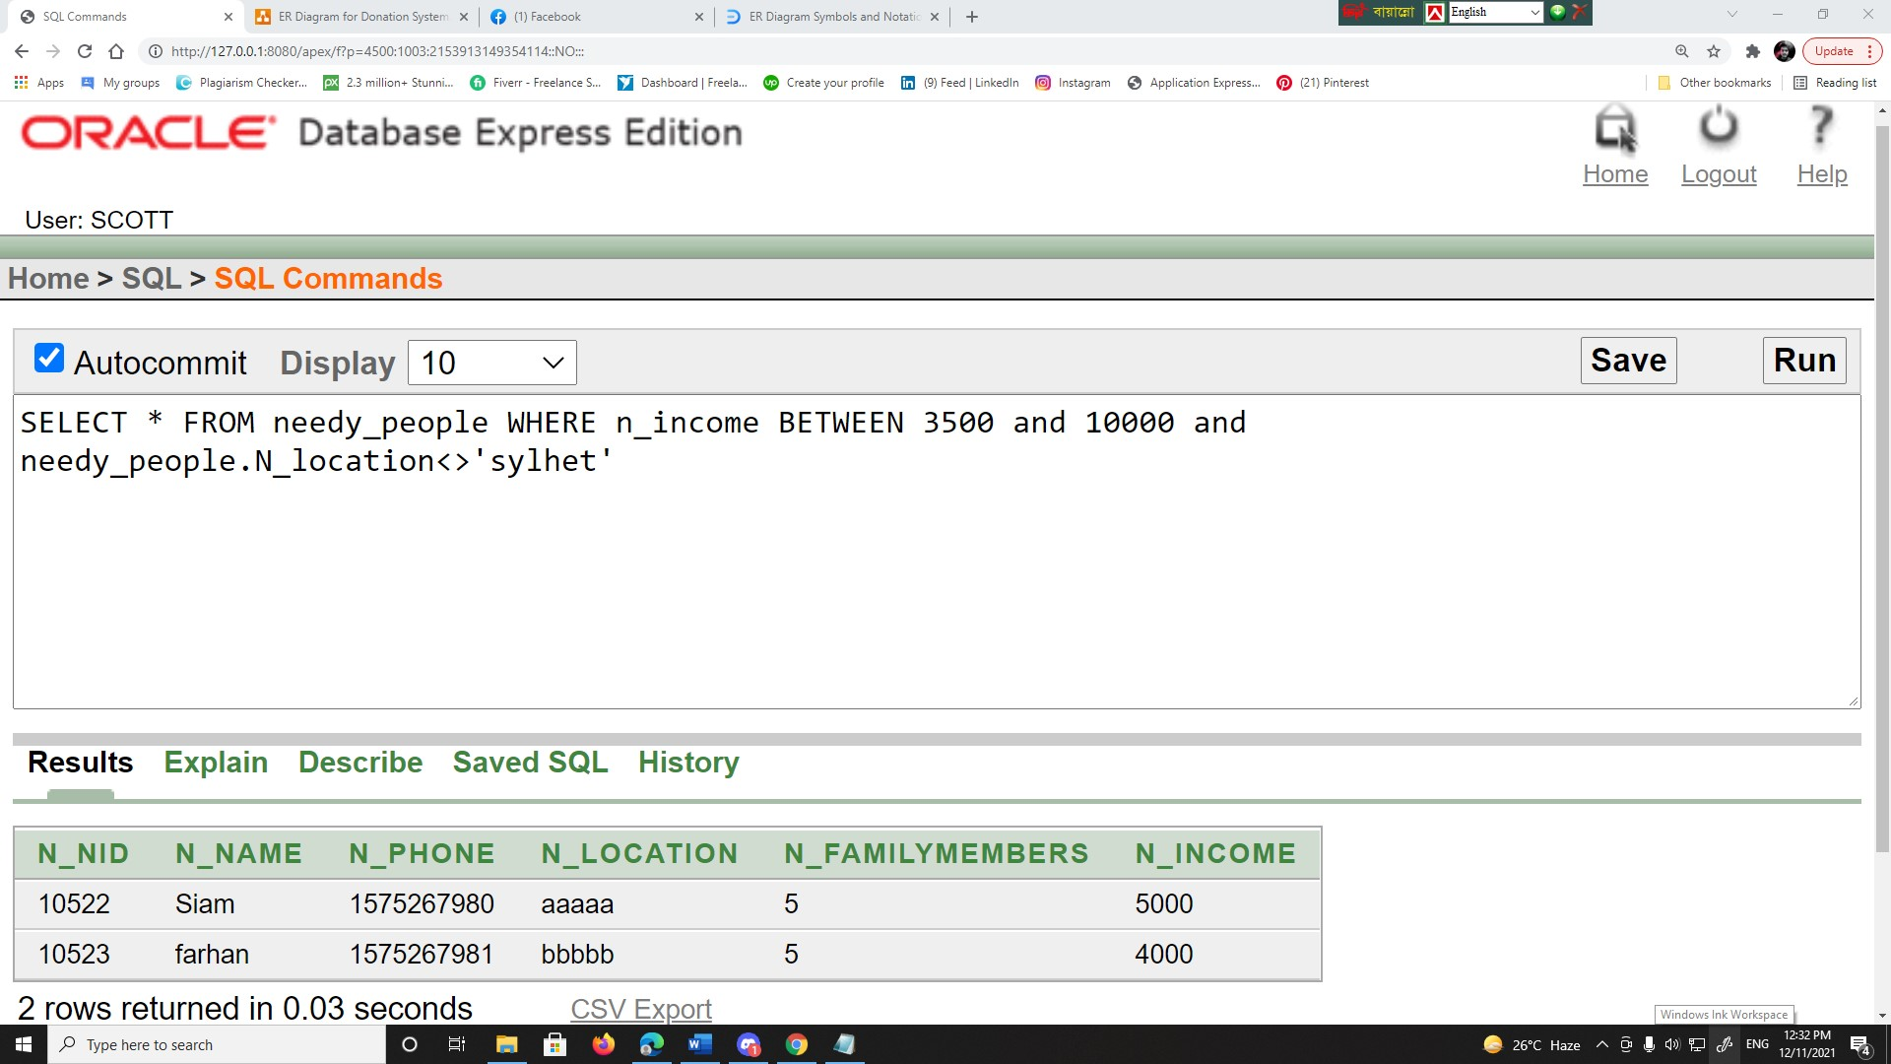

**self Join**

6:

Find out the employees whose salary is greater than Farhan’s salary.

select c.* from charity_employee C,charity_employee e where e.E_name = 'farhan' and e.E_salary<c.E_salary;

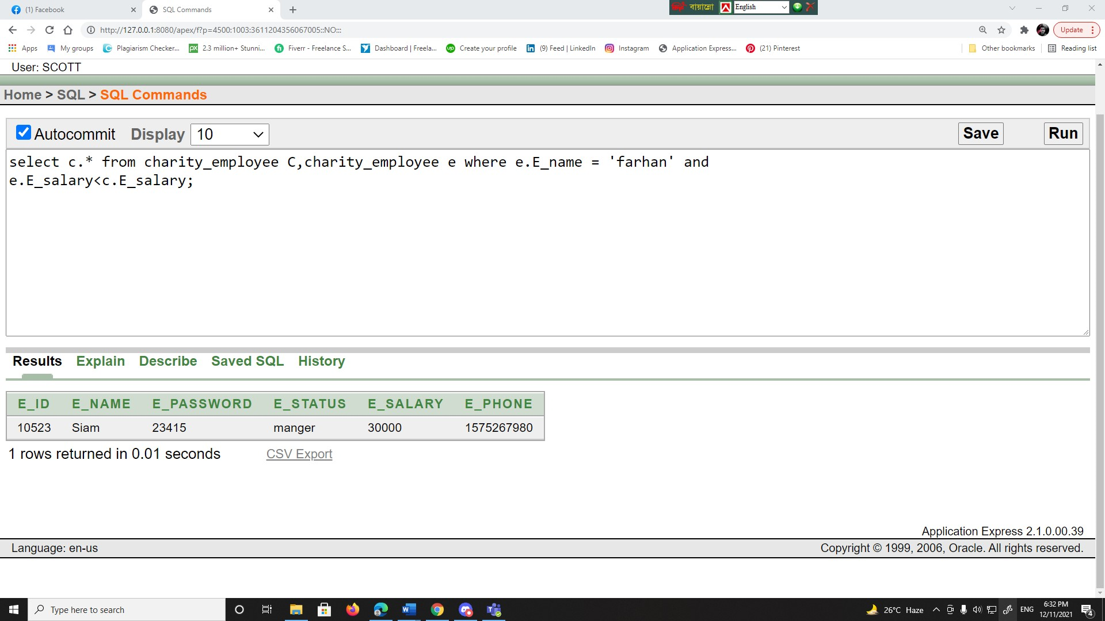

**Inner Join**

7:

Display all info for thouse who have donarted.

SELECT * FROM donator d INNER JOIN Contact_Donator cd on d.D_Nid = cd.Nid ;

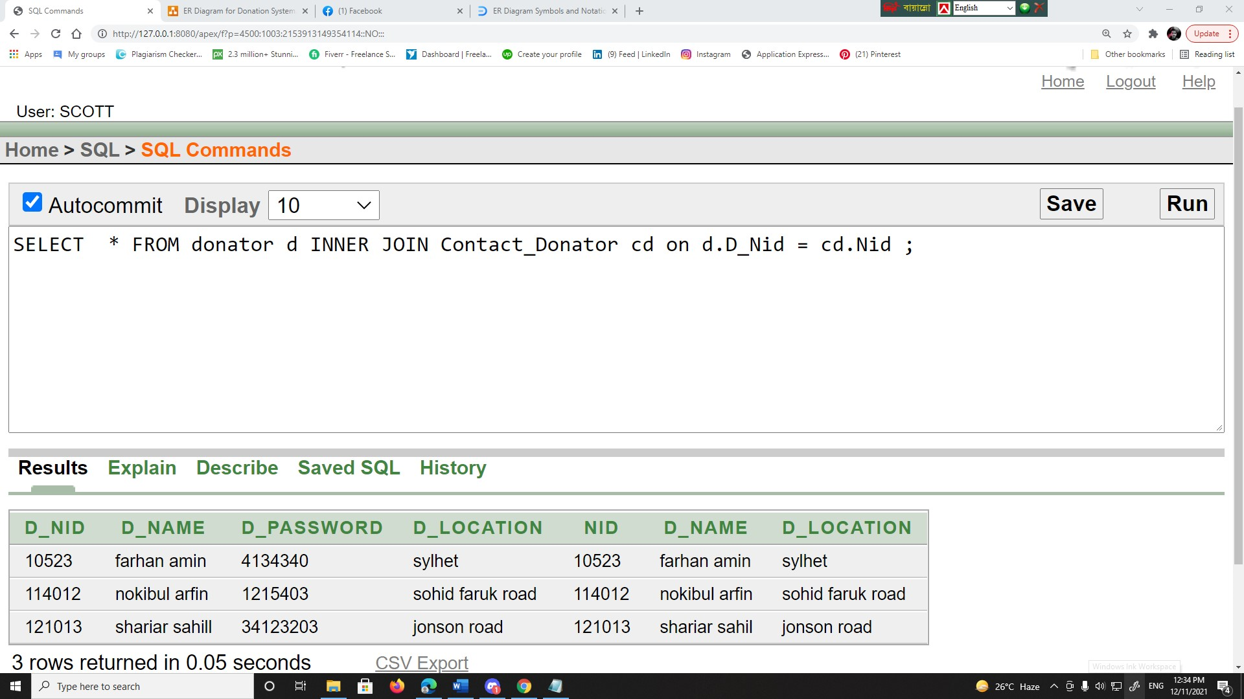

***VIEW***

**Complex View**

CREATE VIEW contact_Npeople as

SELECT np.n_name, np.n_phone, cnp.n_nid, np.n_location

FROM needy_people np INNER JOIN Contact_Needy_people cnp on np.N_nid=cnp.N_nid

SELECT* from contact_Npeople

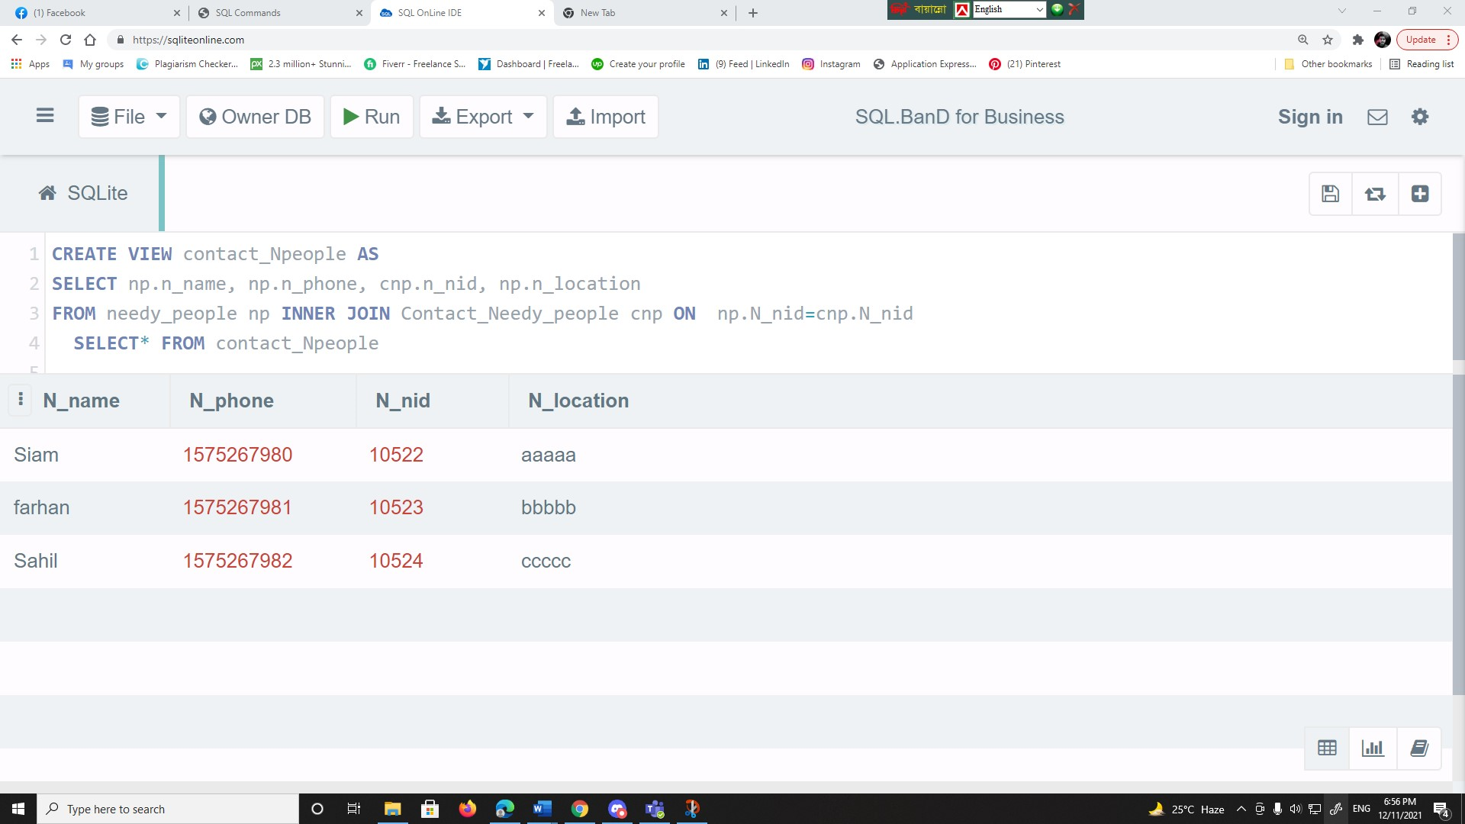

**Simple View**

CREATE VIEW Np AS

SELECT n_nid, N_name, n_location FROM needy_people WHERE needy_people.n_income=5000 ;

Select * from Np

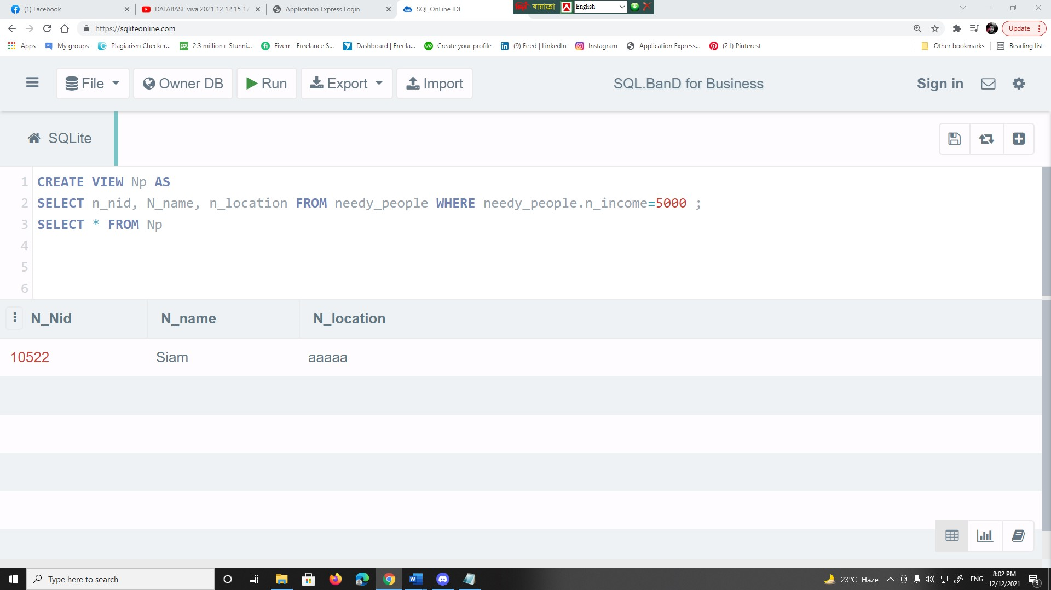

***Constraint***

alter table donator add primary key(D_nid)

desc donator

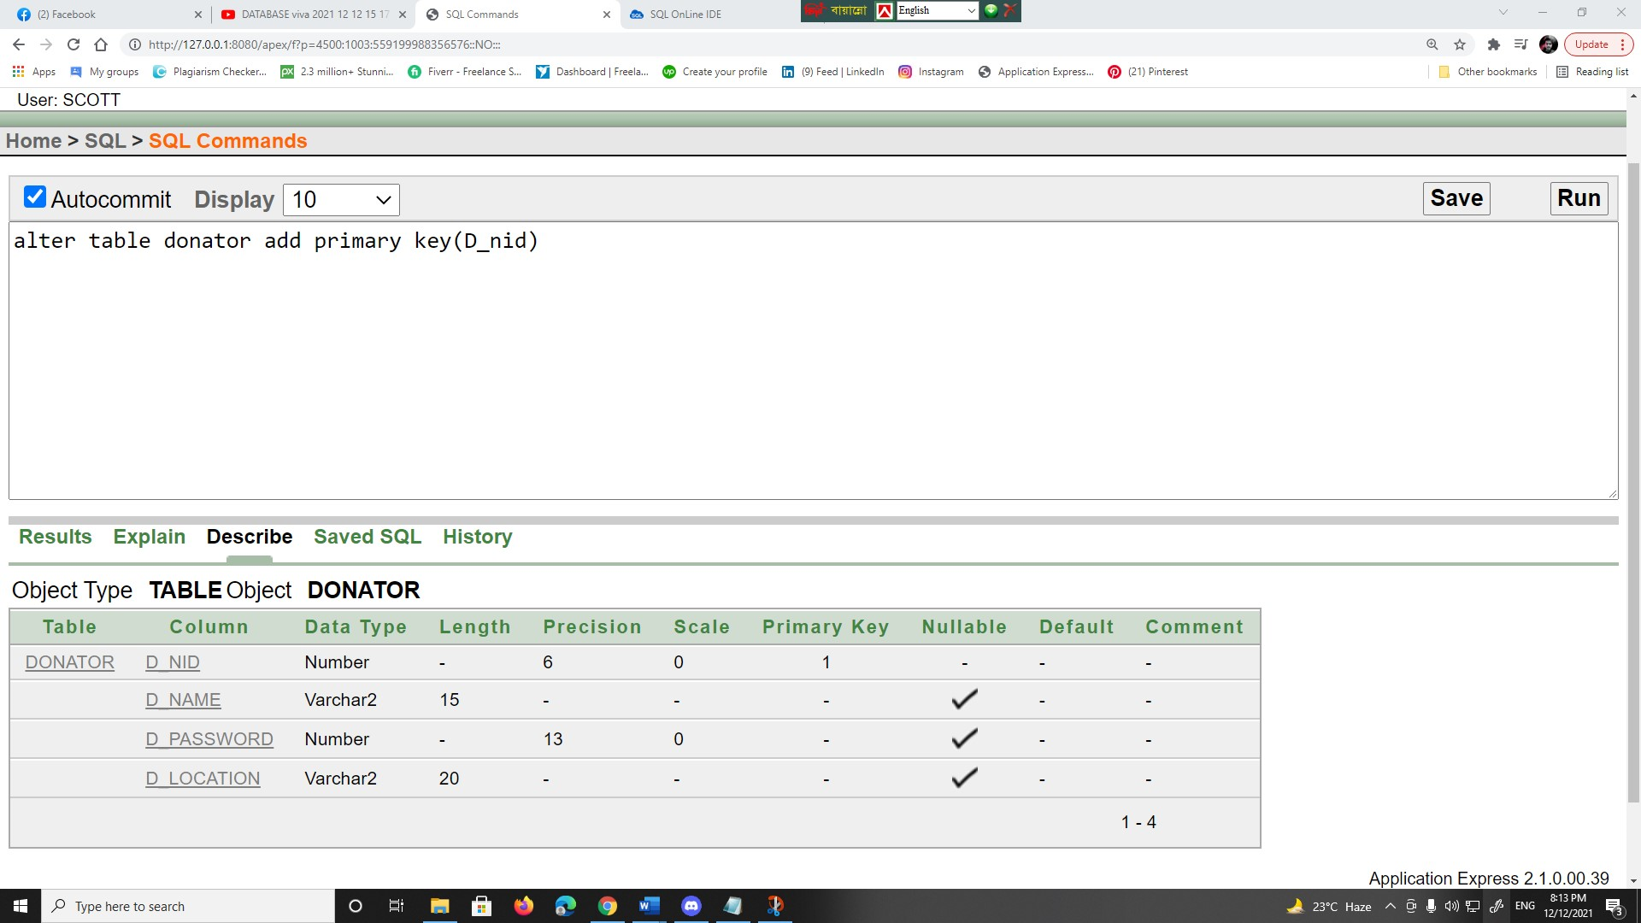

THE END